CROSS TALK~ A Day School

for students of
Catholic University of America
and
George Washington University
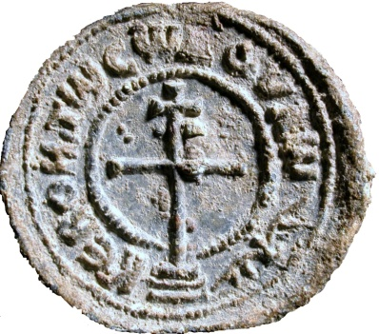
In the Founders’ Room of
DUMBARTON OAKS

MARCH 26, 2011
9:30 am-5:15 pm

PROGRAM
9:30 Introduction: Örgü Dalgiç and Jack Tannous
10:00 Gudrun Bühl, “The Cross Exhibit at Dumbarton Oaks”
10:30-11.30 Gallery Tour by Gudrun Bühl
11.30-12.00 Coffee Break
12:00 Robin Cormack, “The Cross and ʻiconoclasm-denialʼ”
12:40: Lunch
1:40: Group photo
2:00: Henry Maguire, “The Cross in Byzantine Painting”
2:40: Scott Johnson, “The True Cross in Late Antique and Byzantine Literature”
3:20: Tea Break
4:00: Sidney Griffith, “The Cross Between Christianity and Islam”
4:40: Round Table Discussion by speakers
5:05: Concluding Remarks: Örgü Dalgiç and Jack Tannous
CROSS TALK~A Day School

for students of
Catholic University of America
and
George Washington University
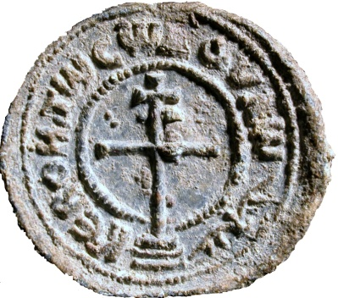
In the Founders’ Room of
DUMBARTON OAKS

MARCH 26, 2011
9:30 am-5:15 pm

PROGRAM
9:30 Introduction: Örgü Dalgiç and Jack Tannous
10:00 Gudrun Bühl, “The Cross Exhibit at Dumbarton Oaks”
10:30-11.30 Gallery Tour by Gudrun Bühl
11.30-12.00 Coffee Break
12:00 Robin Cormack, “The Cross and ʻiconoclasm-denialʼ”
12:40: Lunch
1:40: Group photo
2:00: Henry Maguire, “The Cross in Byzantine Painting”
2:40: Scott Johnson, “The True Cross in Late Antique and Byzantine Literature”
3:20: Tea Break
4:00: Sidney Griffith, “The Cross Between Christianity and Islam”
4:40: Round Table Discussion by speakers
5:05: Concluding Remarks: Örgü Dalgiç and Jack Tannous

