Pagans, Christians and Muslims:
Mediterranean Transitions in the Early Medieval World

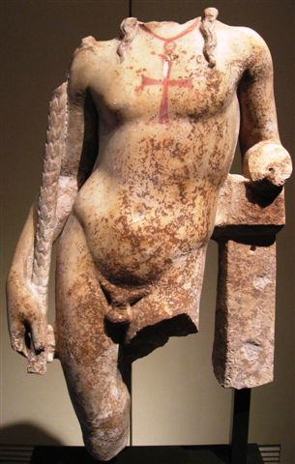
for students of Catholic University of America, Georgetown University, and
George Washington University

In the Founders’ Room of
DUMBARTON OAKS

MARCH 31, 2012
10:00 am-4:pm

PROGRAM

9:30 Coffee
10:00 Introduction: Margaret Mullett
10:15 Scott Johnson, Between Paganism and Christianity
10:45 Jack Tannous, Between Christianity and Islam
11:15 Discussion
11:30 Group Photo
11:45 Lunch and Museum Tours
1:45 Coffee
2:00 Jonathan Shea, Money Talks: Coins, Ideology and Transitions
2:30 Luca Zavagno, Two Hegemonies, One Island: Cyprus Between the Byzantines and the Umayyads
3.00 Discussion
3:15 Concluding Remarks and General Discussion
3:45 Coffee

Pagans, Christians and Muslims:
Mediterranean Transitions in the Early Medieval World

for students of Catholic University of America, Georgetown University, and
George Washington University

In the Founders’ Room of
DUMBARTON OAKS
MARCH 31, 2012
10:00 am-4:pm

PROGRAM

9:30 Coffee
10:00 Introduction: Margaret Mullett
10:15 Scott Johnson, Between Paganism and Christianity
10:45 Jack Tannous, Between Christianity and Islam
11:15 Discussion
11:30 Group Photo
11:45 Lunch and Museum Tours
1:45 Coffee
2:00 Jonathan Shea, Money Talks: Coins, Ideology and Transitions
2:30 Luca Zavagno, Two Hegemonies, One Island: Cyprus Between the Byzantines and the Umayyads
3:00 Discussion
3.15 Concluding Remarks and General Discussion
3:30 Coffee

